Multiple choice section

|  |  |  |  |  |  |  |  |  |
| --- | --- | --- | --- | --- | --- | --- | --- | --- |
| Question | 1 | 2 | 3 | 4 | 5 | 6 | 7 | 8 |
| Answer | A | D | C | D | A | D | D | A |

Question 1 [12.1]

A

The equation must not be of the form .

Question 2 [12.4] [10A]

D

36= (62) = 6

Question 3 [12.3]

**C**

8x4 × 2x6 = 8 × 2 × x4 + 6

= 16x10

Question 4 [12.3]

**D**

(4x6)3 = 41 × 3x6 × 3

= 43x18

= 64x18

Question 5 [12.5] [10A]

A

(32) = (25)  
= 5(2) = 5

Question 6 [12.5] [10A]

**D**

= 

= (52)

= -2(5) = -2

Question 7 [12.1]

D

As the value of x becomes very large, 5-x becomes very small and the value of y approaches 3, a horizontal asymptote.

Question 8 [12.2]

A

The graph of the equation is a circle with centre (0, 0) and radius 2.

Multiple-choice results: 8

Short answer section

Question 10 2 marks [12.5] [10A]

In the term 5x6, the ‘6’ is known as the exponent or index of x.

Question 11 1 mark [12.5] [10A]

(243) = 5 because 3 raised to the power 5 equals 243.

Question 12 2 marks [12.4] [10A]

 = 

= 

= 

Question 13 2 marks [12.3]

6a2b5 = 

Question 14 2 marks [12.3]

(x2y4)3 = x6y12

= 

Question 15 6 marks [12.5] [10A]

|  |  |  |
| --- | --- | --- |
| **(a)** (32) + (2) = (32 × 2) = (64) =  = 3(4) = 3 | **(b)** (252) – (7) = = (36) = (62) = 2(6)= 3 | **(c)** 2 =  =  = -1 = -1 |

Question 16 6 marks [12.2]

(a) (x – 2)2 + (y – 1)2 = 4

(b) 2 units right and 1 unit up gives a centre of (2, 1).

(c) r = 2

(d)

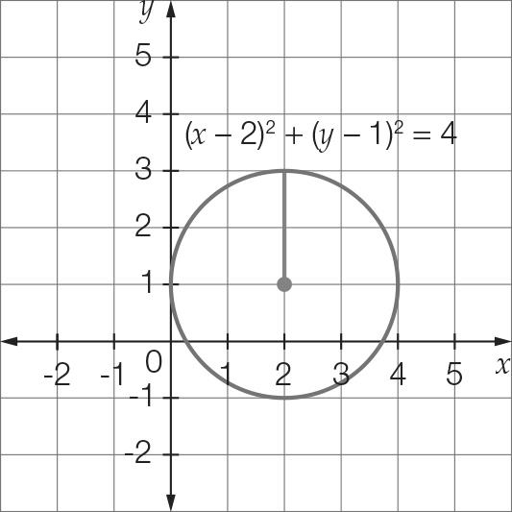

Question 17 4 marks [12.2]

(a) y = 4(x – 2) + 1

(b)

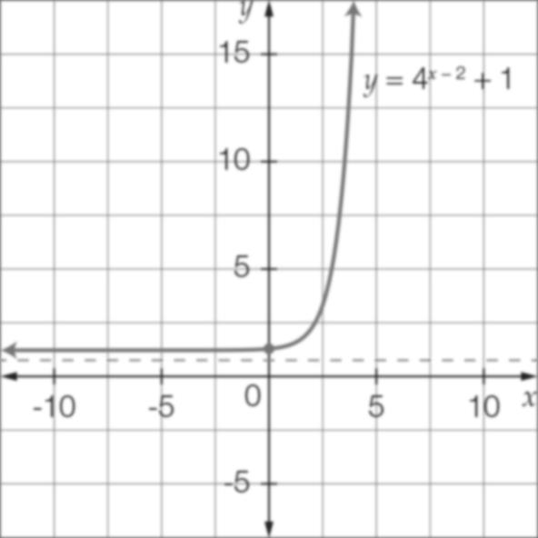

Question 18 6 marks [12.2]

(a) y = + 1

(b) x = 3

(c) y = 1

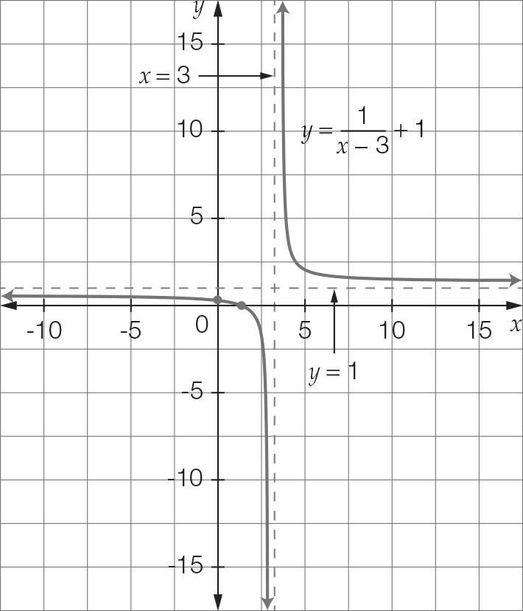

Short answer total: 31

Extended answer section

Question 19 8 marks [12.2]

(a) (x + 3)2 + (y − 1)2 = 4

(b)

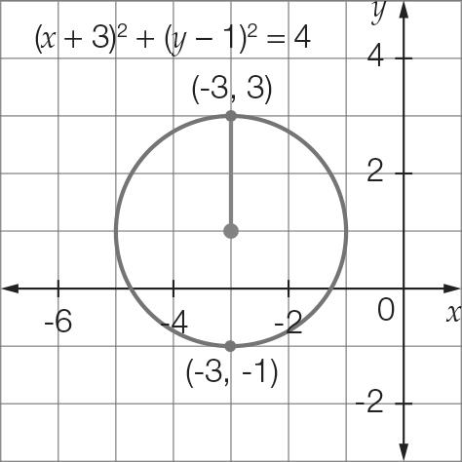

(c) r = 2 originally. An increase of 1 unit so r = 3  
The new equation is(x + 3)2 + (y − 1)2 = 9

(d)

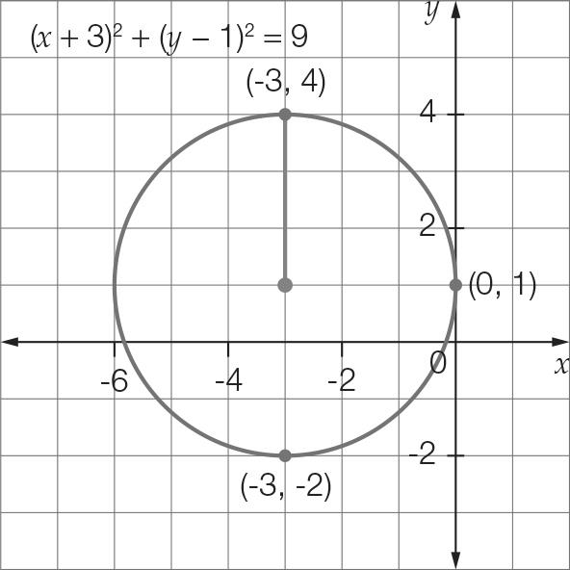

(e) The centre is (-3, -1). The radius is unchanged, so r = .

Question 20 8 marks [12.2]

(a) Initial temperature occurs when t = 0.

  
For t = 0  
T = 30+ 2  
T = 1 + 2  
 T = 3

So the initial temperature of the vintage clothes iron is 3 °C.

(b) For t = 3  
T = 33 + 2  
T = 27 + 2  
 T = 29

So the temperature of the vintage clothes iron after 3 minutes is 29 °C.

(c)

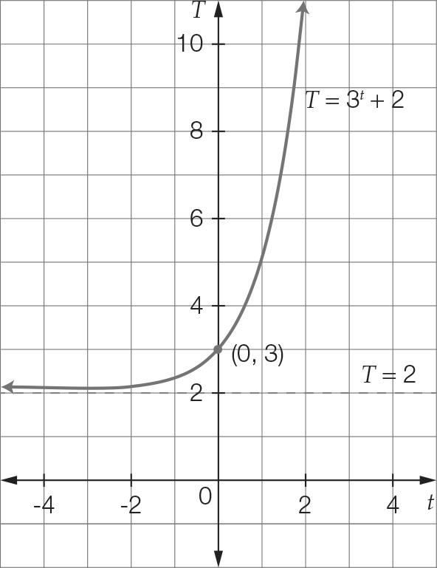

(d) For t = 4  
T = 34 + 2  
T = 81 + 2   
T = 83 °C  
Temperature difference  
= 83 – 3  
= 80 °C

Extended answer total: 16

TOTAL test results: 55